University of Science – VNUHCM

Faculty: Information Technology

Major: Advanced Program in Computer Science

TECHNICAL REPORT

CS162 – solo project

Student: Lê Đại King

ID student: 23125010

Class: 23APCS2

# Creating a GitHub Private Repository

To create a github private repository, I did the following these steps:

1. Logged in GitHub.
2. A screenshot of a computer

   Description automatically generatedClicked a button “+” in top – right corner and selected “new repository”:
3. Filled in the necessary information and chose a private mode:
4. A screenshot of a computer

   Description automatically generatedFinally, clicked “create repository”.

# Cloning GitHub Repository to Local

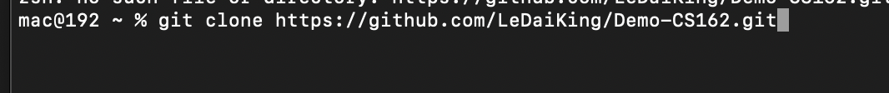After having a repository, I opened terminal and run this command to clone repository:

# Organizing Source Code

Next, I opened the repository that cloned on my local and created a folder name “Source Code” that will contain my codes:

# Adding a “.gitignore“ file

To ignore certain files from being tracked by Git, I created a “.gitignore” file in the root directory of my project. I added file patterns or directory names to this file to specify what should be excluded from version control.

Besides, I can also add a “.gitignore” file when creating a new repository:

# Git Operations

1. A screen shot of a computer

   Description automatically generatedgit status: I used this command to show status of repository:
2. git add .: used to stage changes for commit
3. A screen shot of a computer program

   Description automatically generatedgit commit -m "update": Commits the staged changes to the local repository along with a commit message.
4. A screenshot of a computer program

   Description automatically generatedgit push: Push commit changes to the remote repository on GitHub
5. A screen shot of a computer

   Description automatically generatedgit pull: Pull changes from remote repository to the local one, merging them into the current branch.

# Python Project Structure

Python projects commonly have a structure like this:

Source Codes/

main.py

module1.py

module2.py

Note: “main.py” serves as the entry point, and other modules contain reusable code.

# Writing Source Code in Multiple Files

Each file typically represents a module or a class, and related functionalities are grouped together for better organization and maintainability.

To use functions in other file, I used command “import namefile” with namefile is name of file python containing functions.

To use classes in other file, I used “from namefile import nameclass” with namfile is name of file containing classes and nameclass is name of class that I need to import.

# Creating Classes, Properties, and Methods

In Python, classes are created using the class keyword, and they can contain properties (attributes) and methods.

Example:

MyClass has two properties (prop1 and prop2) and two methods (method1 and method2).